COMMANDS

grep ‘Linux’ “Desktop/Demo/B”:

grep -i ‘linux’ “Desktop/Demo/B”:

grep -i -c ‘linux’ “Desktop/Demo/B”:
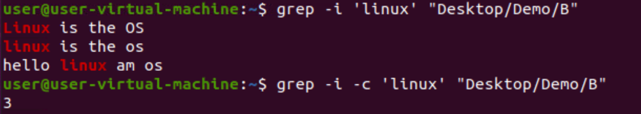
grep -l ‘linux’ *:

grep -w ‘linux’ B:
grep -wi ‘linux’ B:

grep -o ‘linux’ B:
grep -ow ‘linux’ B:

grep -owi ‘linux’ B:

grep -n ‘linux’ B:
grep -in ‘linux’ B:

grep -inow ‘linux’ B:

grep -v ‘OS’ B:
grep -vi ‘linux’ B:
grep -vin ‘home’ B:
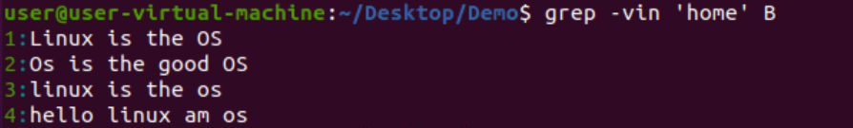
grep ‘^Os’ B:
grep -i ‘^linux’ B:
grep ‘os$’ B:

grep -i ‘os$’ B:
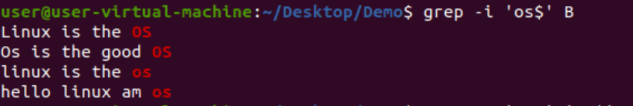
grep -E ‘^hello.*hello$’ B:
grep -ni -E “^h[i]p$” D:
grep -ni -E “^h[il]p$” D:
grep -ni -E “^h[io]p$” D:
grep -ni -E “^h[lio]p$” D:
grep -ni -E “^h.p$” D:
grep -ni -E “^h.*p$” D:
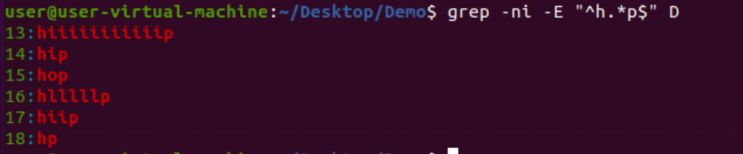
grep -ni -E “^h[i]p$” D:
grep -ni -E “^h.[i]p$” D:
grep -ni -E “^h.[i]*p$” D:
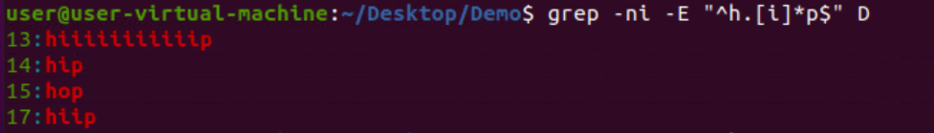
grep -ni -E “^h[i]*p$” D:
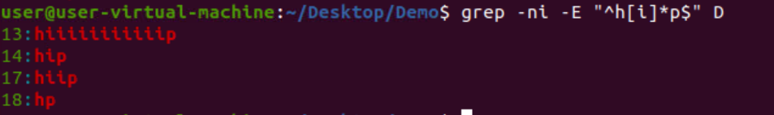
grep -ni -E “^hi+p$” D:

grep -ni -E “^h[i*]p$” D:
grep -ni -E “^h[i.*]p$” D:
grep -ni -E “^[A-Z].*” D:
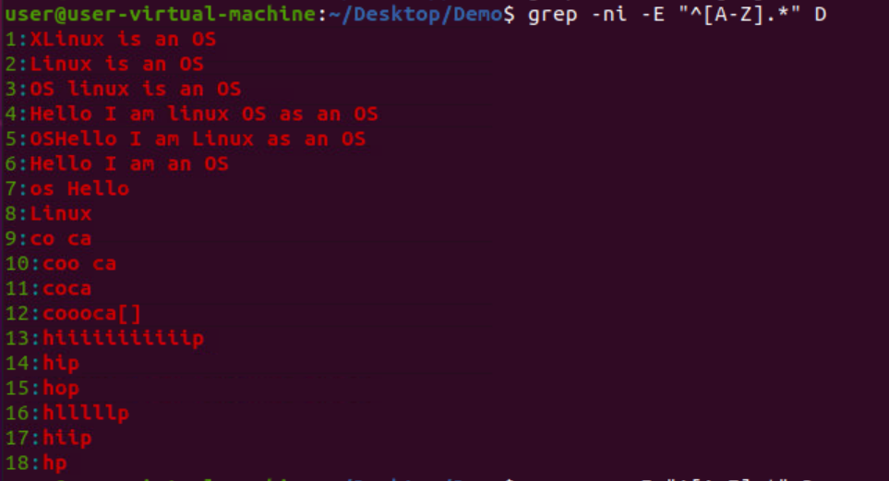
grep -ni -E “^h[.i*]*p$” D:
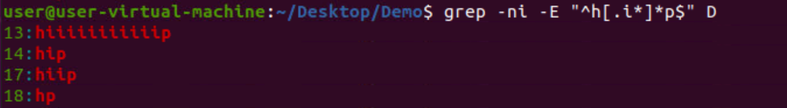
grep -ni -E “^h[i]+p$” D:

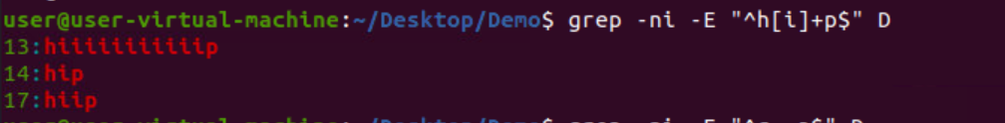
grep -ni -E “^c..a$” D:

grep -ni -E “^c. .a$” D:
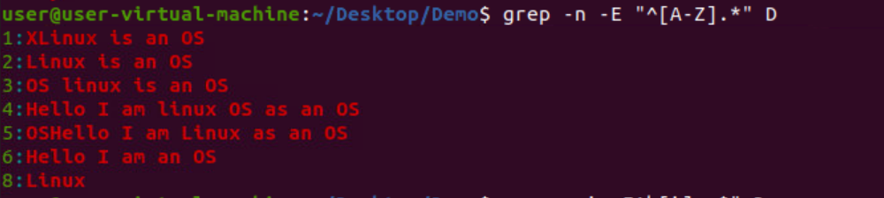
grep -n E “^[A-Z].*” D:
cut -c 1 – D:
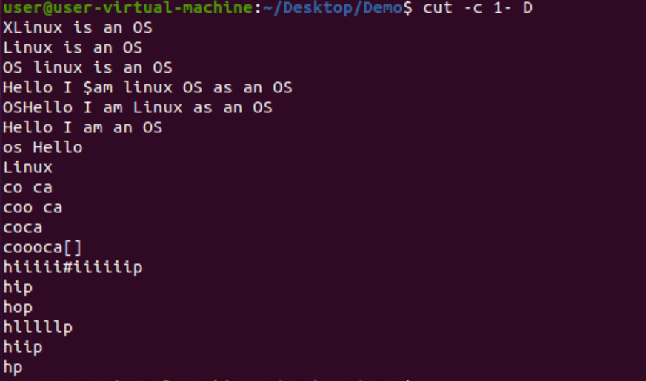
cut – c 1 – 5 D:

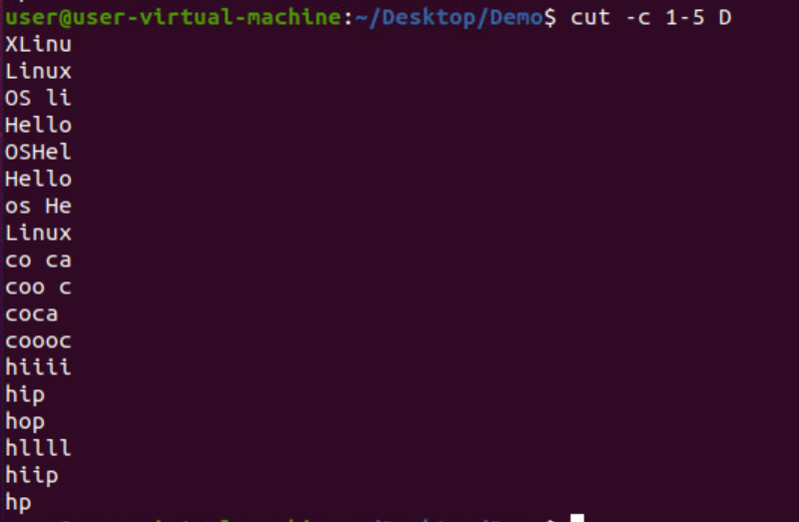

cut -d ‘ ‘ -f 3 D:
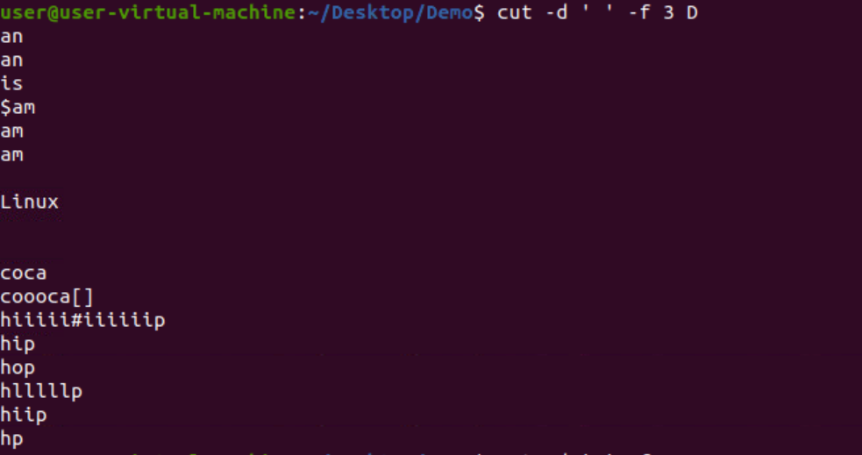
cut -b 1 – 4 D:
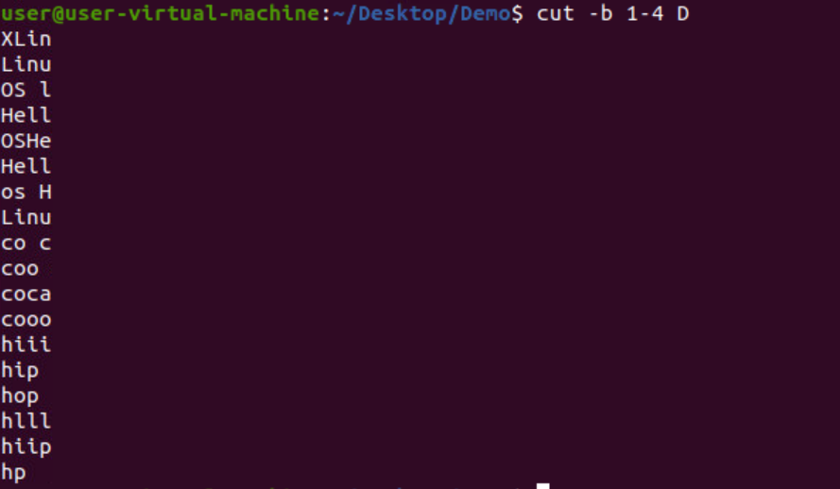
cut -c -5 D:
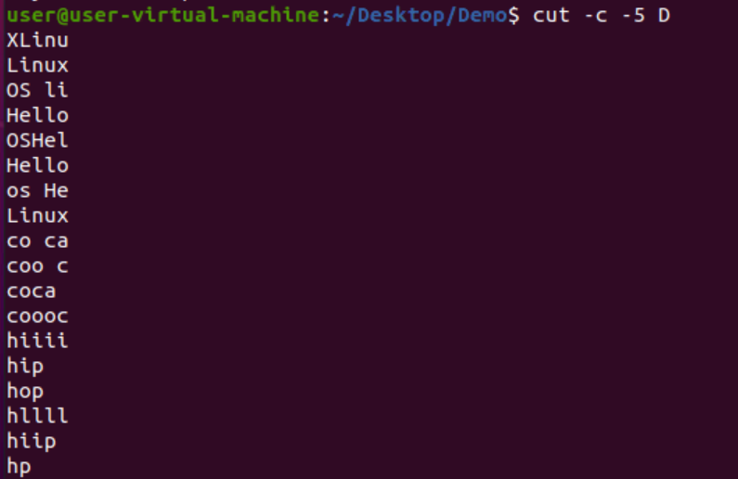

cut -d ‘ ‘ f 1 – 3 D:
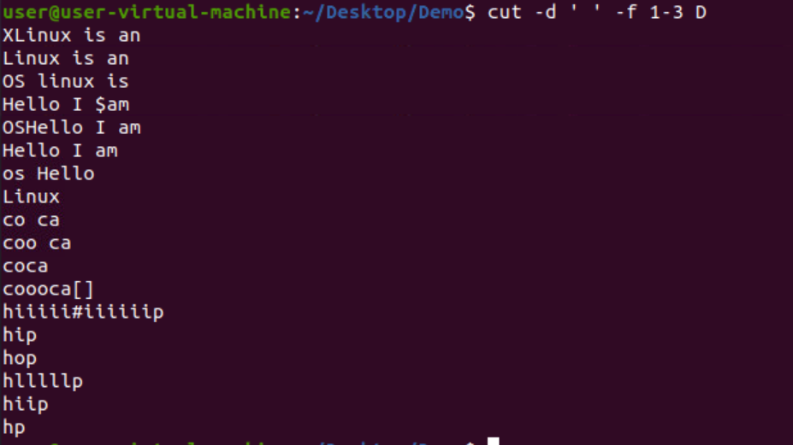
cut -d ‘s’ -f 1 D:
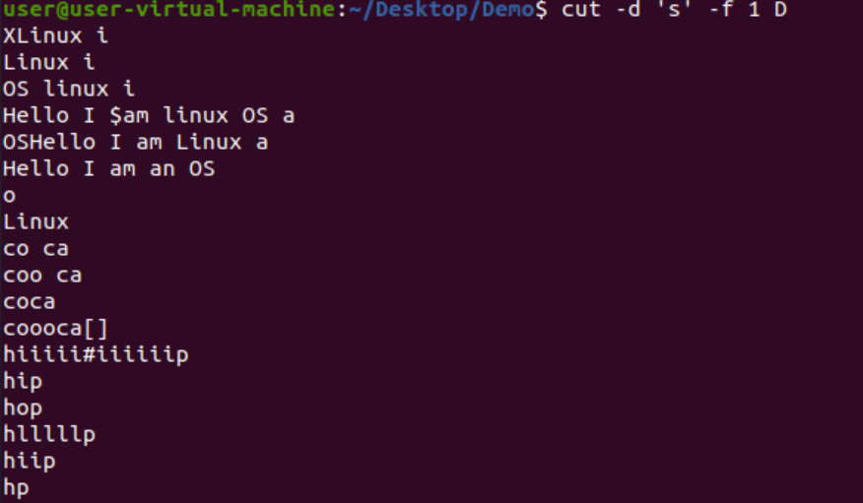
cut -d ‘$’ -f 1 D:
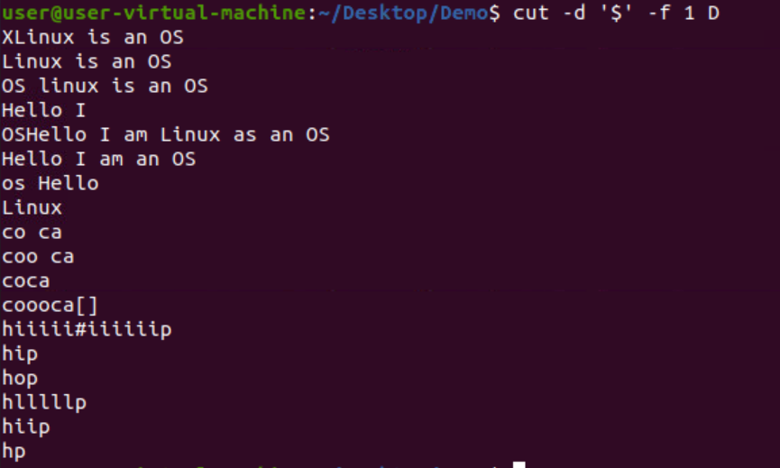

cut -d ‘.’ -f 1 D:
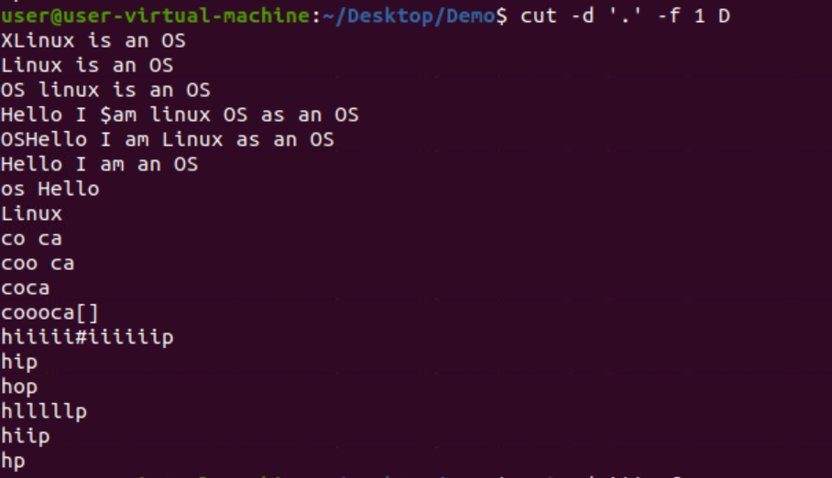
cut -d ‘s’ -f 2 D:
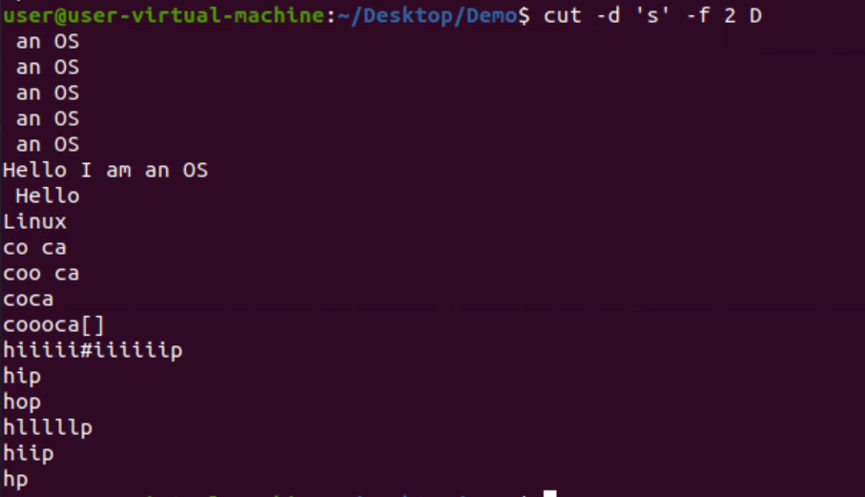
cut -c 1,5 D:
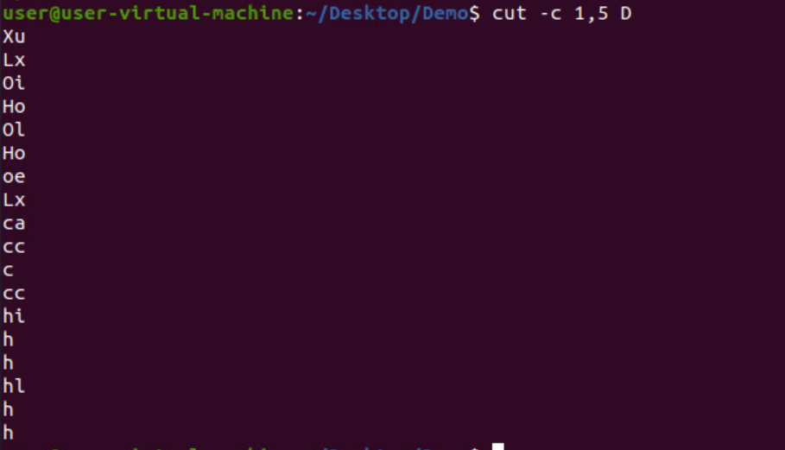

cut –complement -c 1,5 D:
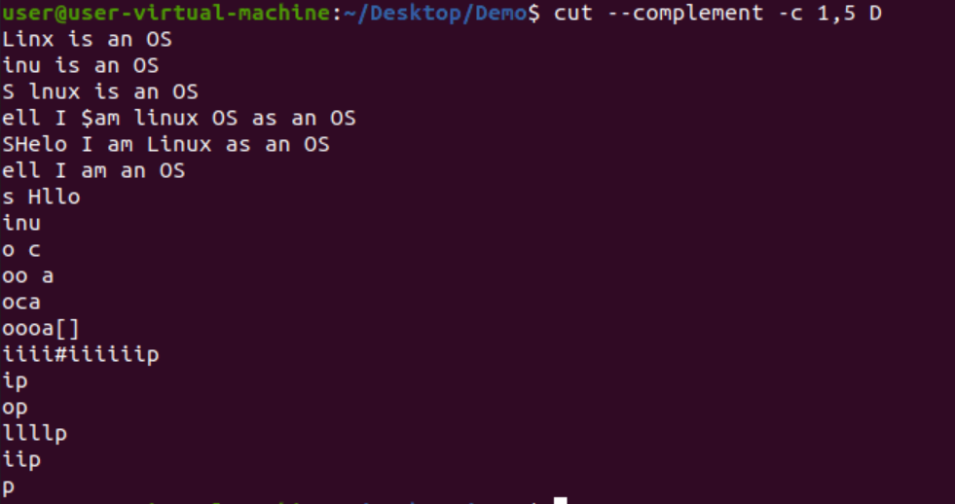
cut -d ‘ ‘ -f 1 -2 D –output-delimiter=’*’:
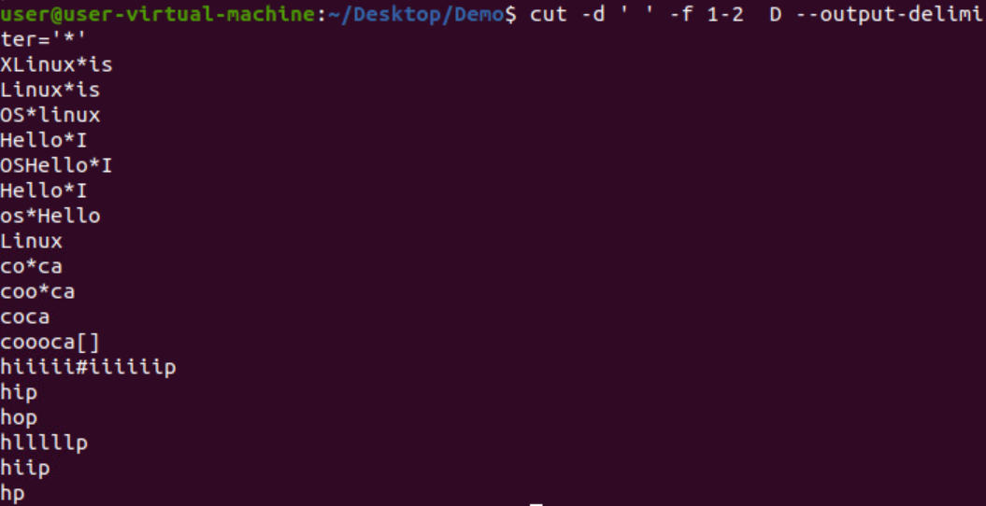
cut -d ‘ ‘ -f 1 D|sort:
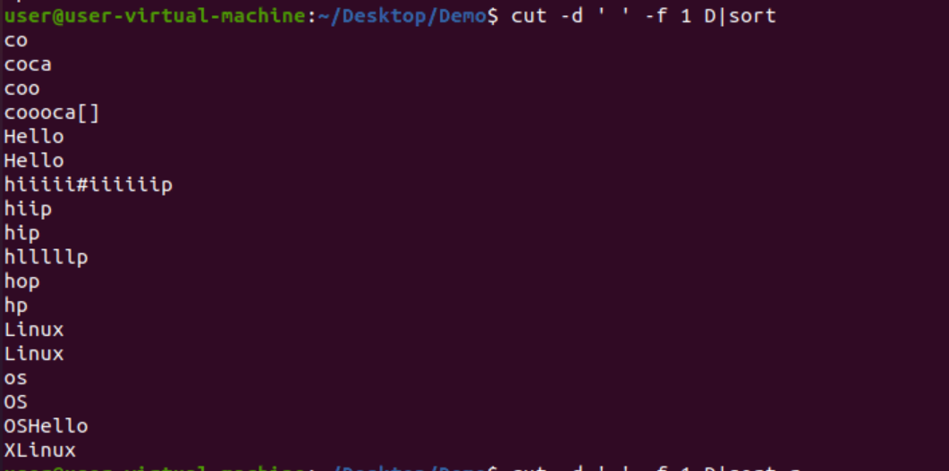

cat C|tr ‘[a-z]’ ‘[A-Z]’:
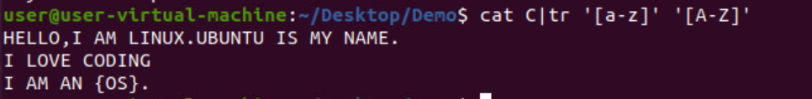
echo :
cat C|tr [:I] ‘k’:

cat C|tr ‘i’ ‘k’:

cat C|tr -d ‘[:digit:]’:
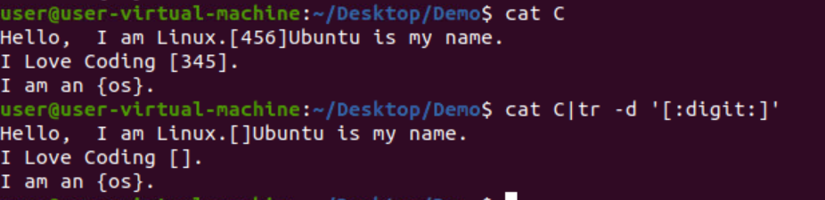
cat C|tr -d ‘[:space:]’ ‘\n’:
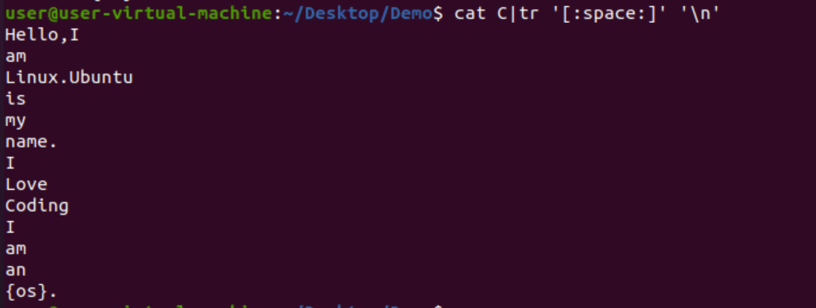

cat C|tr ‘[H]’ ‘[o]’:
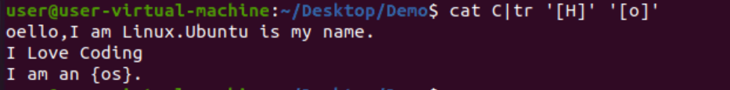
cat C|tr -s [:space:] ‘ ‘:
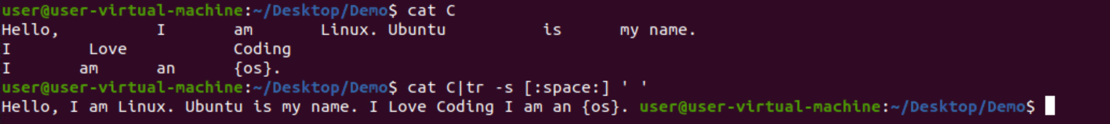
cat C|tr -d ‘I’:
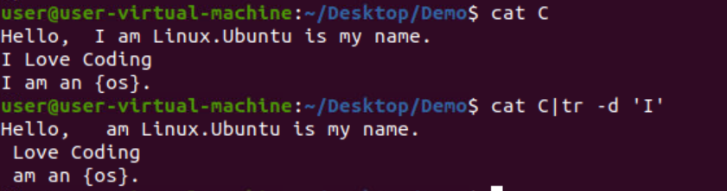
cat C|tr -d ‘[:lower:]’:
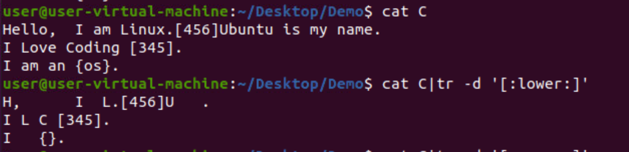
cat C|tr -d ‘[:upper:]’:
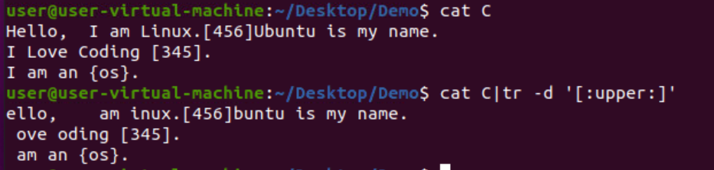

more data:
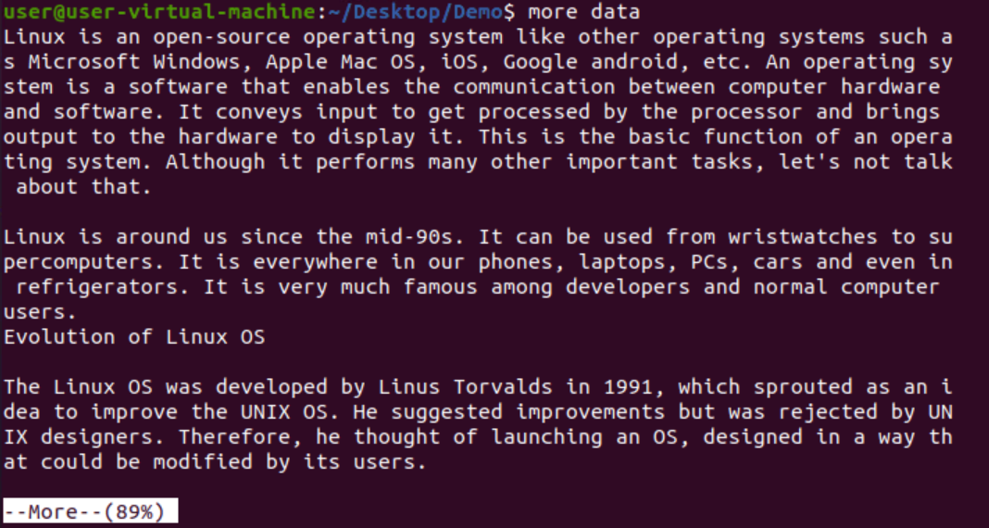
more -d data:
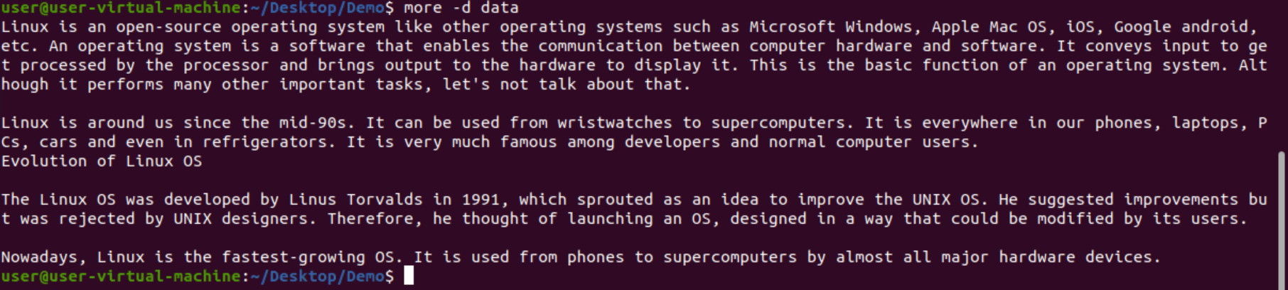
more -p data:
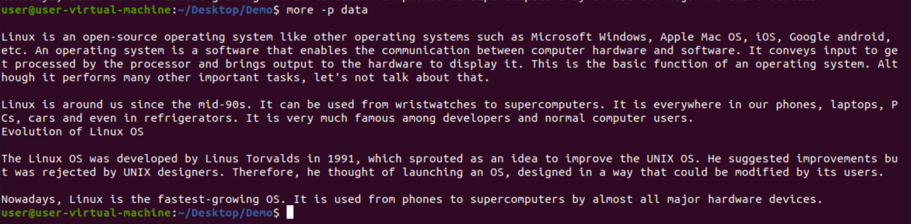

more -s data:
